1. Create VPC with 2 private and 2 public subnets

* Go to vpc dashboard then click on the creat vpc.then give the name tag and give the ip address.the address should be between 16bit to 32bit
* then go to the subnet and click on the create subnets then give the details and ip sddress .I have create two public and private subnets

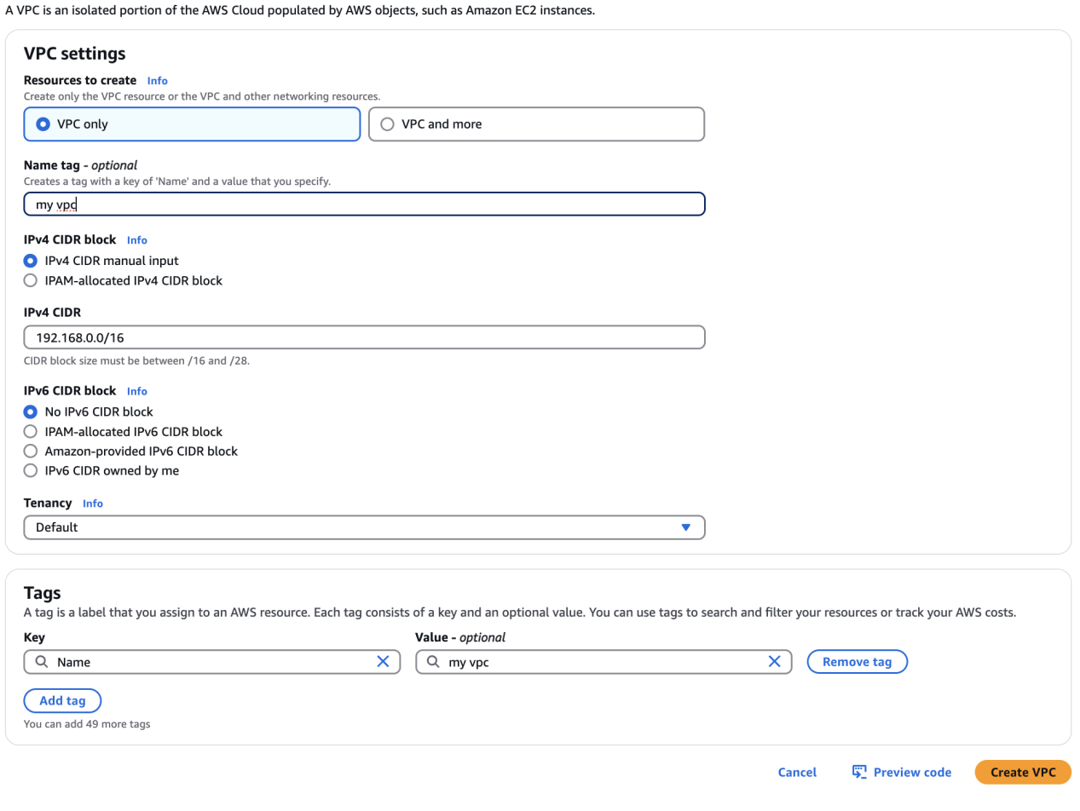

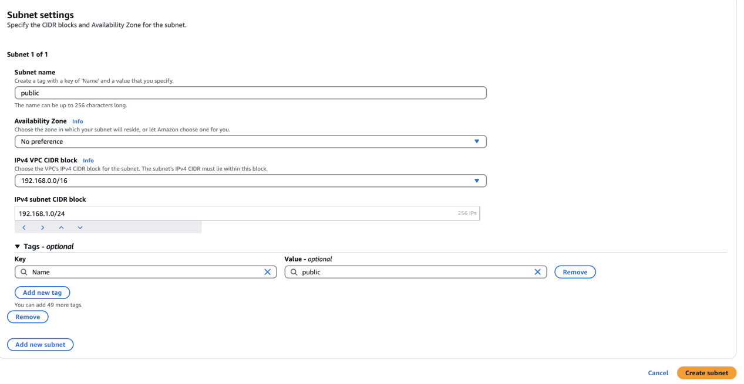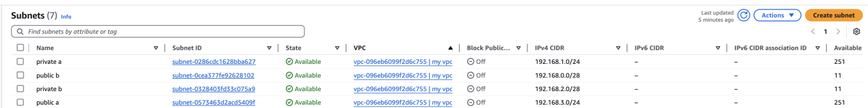

1. Enable DNS Hostname in VPC

* firstly go to action. it should be on right side top. in that go to edit vpc settings.
* In that vpc settings click on enable DNS hostname

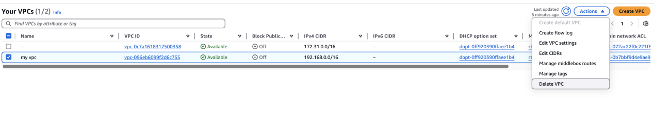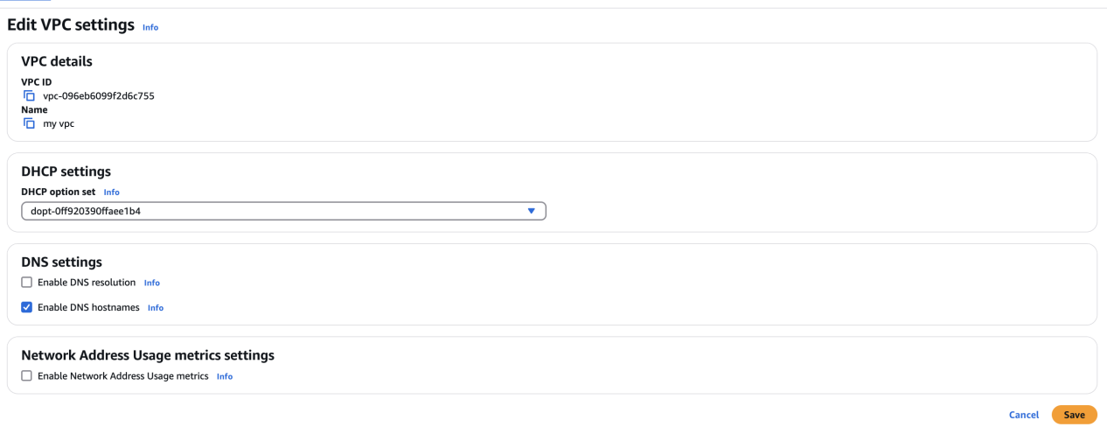

1. Enable Auto Assign Public ip in 2 public subnets

* click on subnet public .go to actions and click on edit subnets.
* Go to auto assign ip setting and then click on enable option click on save.

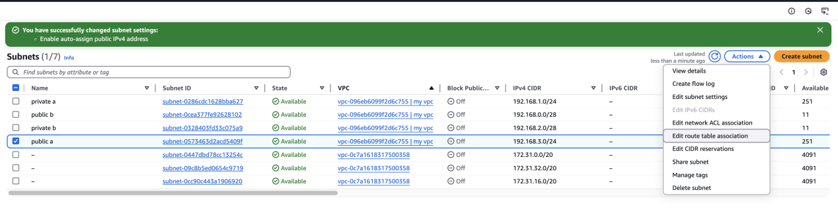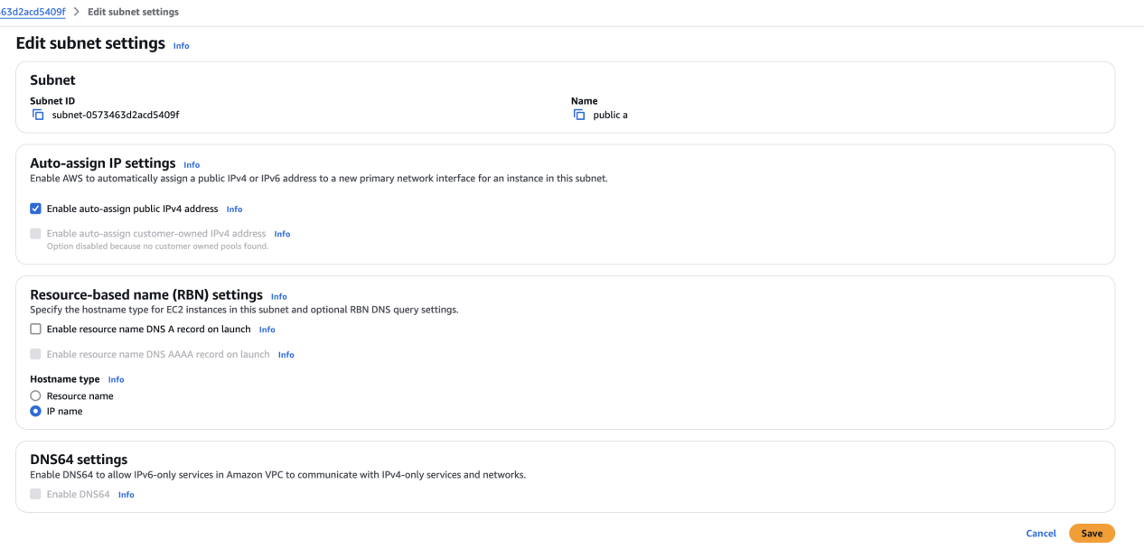

1. Add 2 private subnets in private route table

* first create the rout table with vpc
* select on private in route table
* click on actions and then click on edit subnet associations
* In that click all the private subnets and save the associations

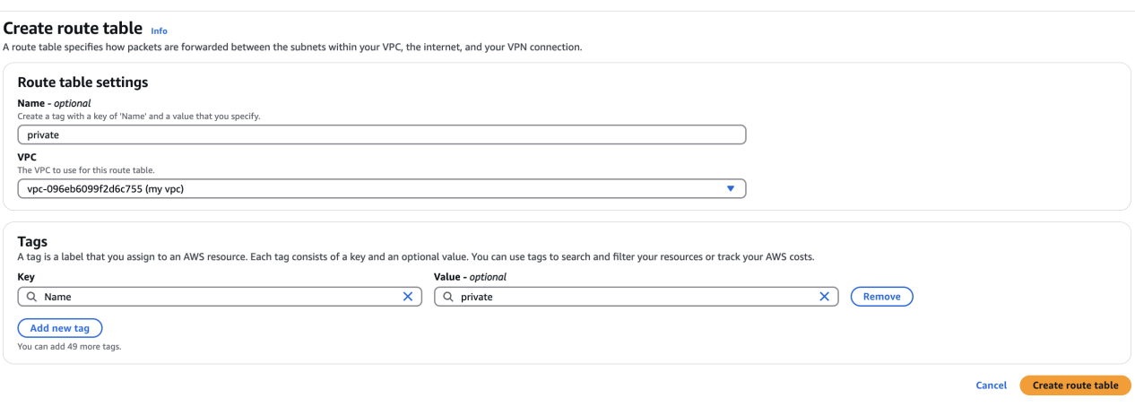

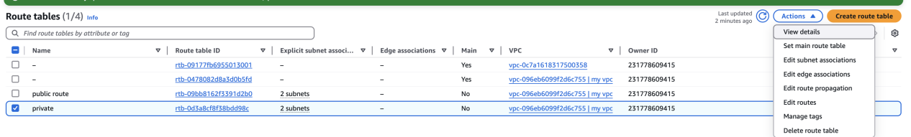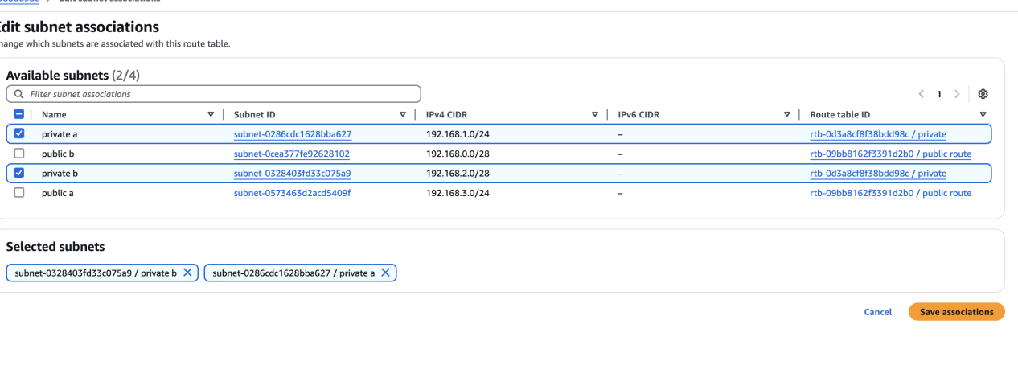

1. Add 2 public subnets vin public route table

* first create the rout table with vpc
* select on public in route table
* click on actions and then click on edit subnet associations
* In that click all the public subnets and save the associations

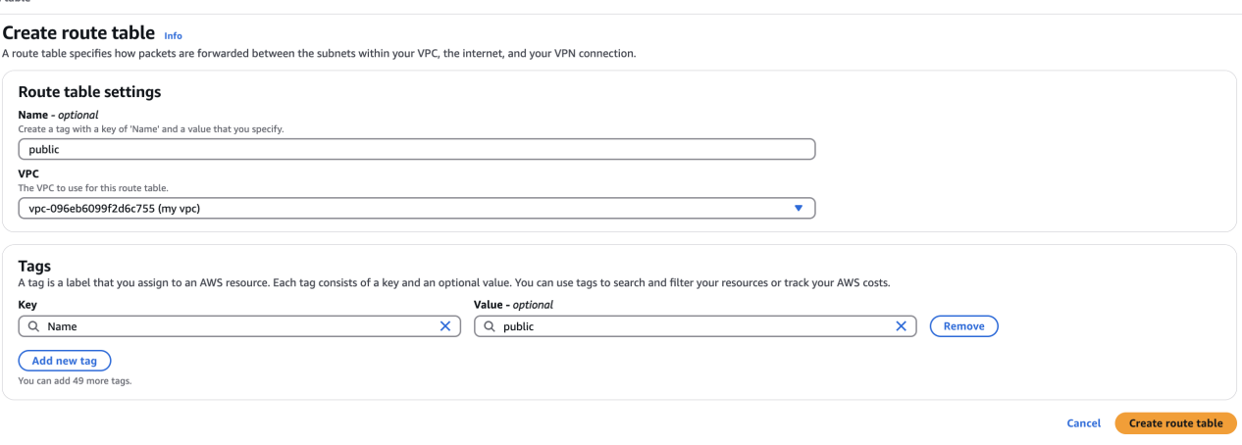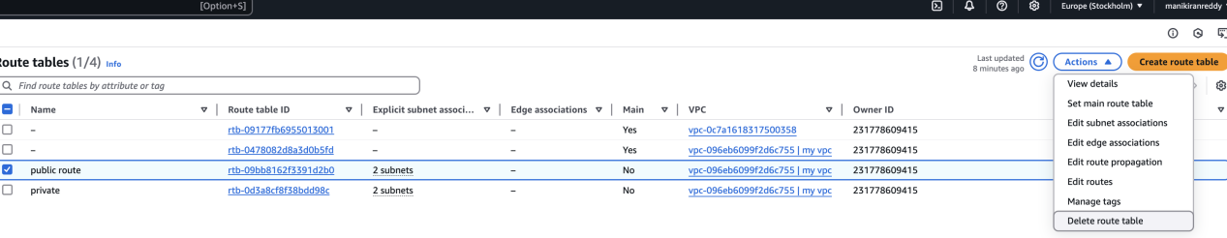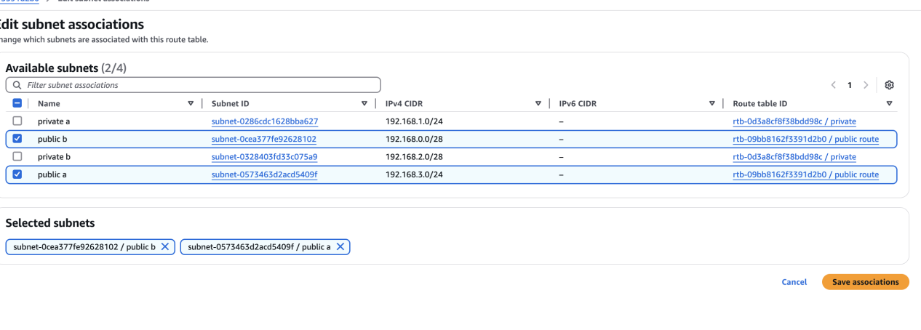

1. Public route table will have the routes to internet and local

* in the route table
* go to routes option and click on edit routes
* then give the destination to 0.0.0.0/0 and in the target select option internet gateway and save the changes

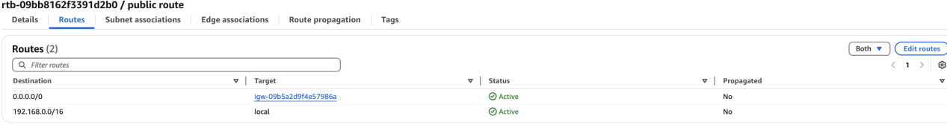

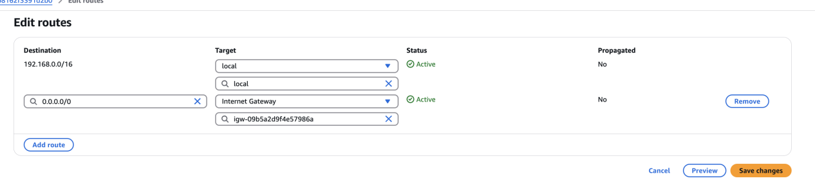

1. Create Ec2 in public subnet with t2

* first launch the instance with the t2 micro and then go to the network settings
* and select the my vpc and in the subnet slect public
* make sure public assign is enable
* create security groups ip to 80 port
* then launch the ec2 in gitbash

for intall cammands are :

* sudo yum update -y
* sudo amazon-linux-extras enable php8.0
* sudo yum clean metadata
* sudo yum install -y php php-cli php-mysqlnd

for php deployment location var/www/html/info.php

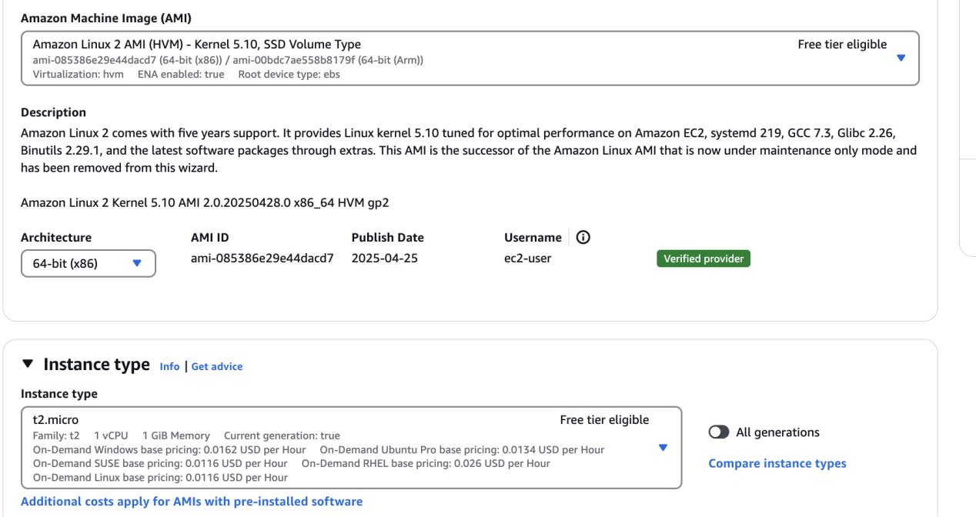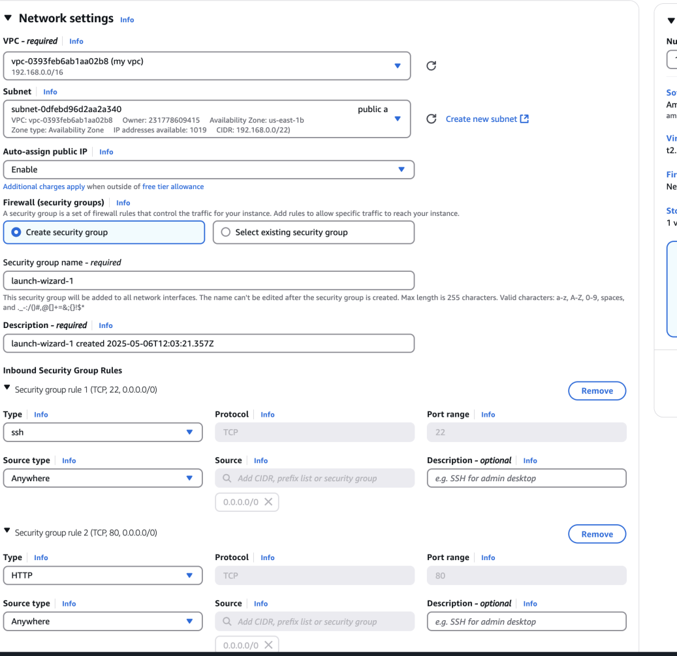

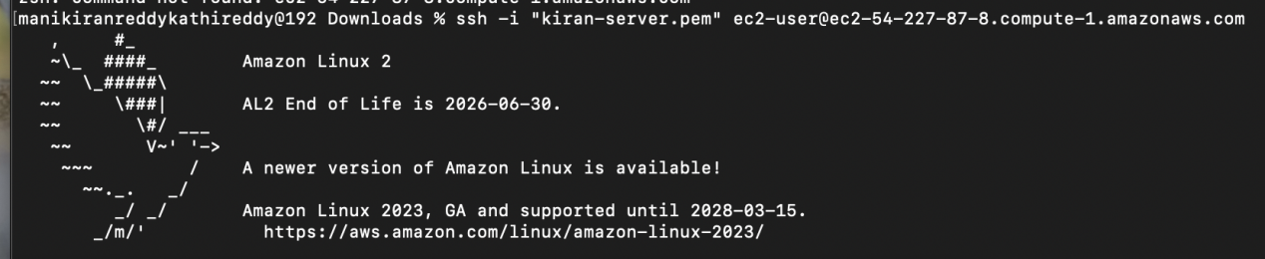



1. COnfigure Nat gateway in public subnet and connect to private Instance

* go to nat gatway and create the nat gateway with public
* then go to route and connect nat gateway ip 0.0.0.0/0
* go to instance and connect public to server
* in the ec2 public creat a test.pem and paste the main pem key server
* then change the permissions to the test.pem
* and connect to the privet key the test.pem
* to verify ,nat after the connection the pin the google

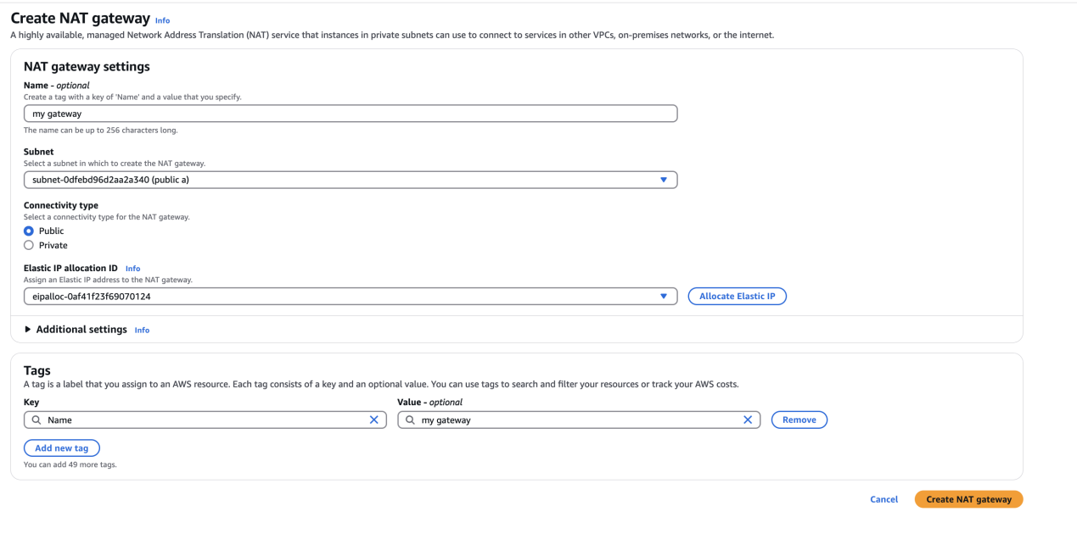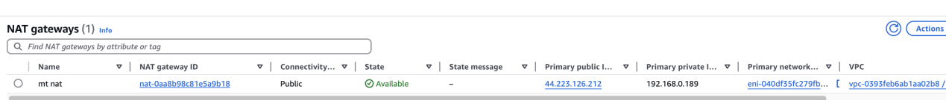

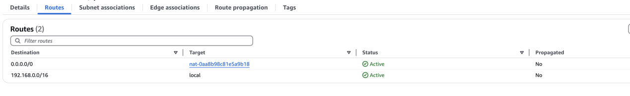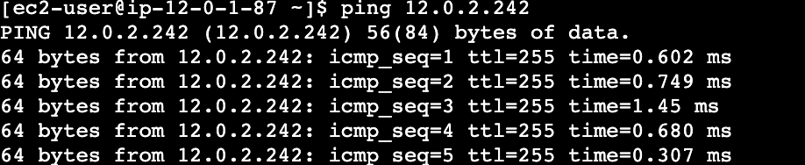

1. Install Apache Tomcat in private ec2 and deploy a sample app.

* Go to the private server ec2 and install thhe apache tomcat
* enter the wget <https://dlcdn.apache.org/tomcat/tomcat-9/v9.0.104/bin/apache-tomcat-9.0.104.tar.gz>
* then one tar file is created
* that tar file should be extrated from tar -xvzf (tar file name )
* then change the extract file name to tomcat
* remove the rarfile with rm -rf
* all tomcat deployment logs in webpages

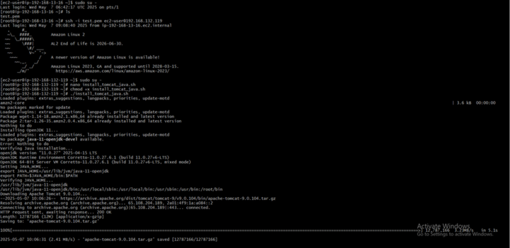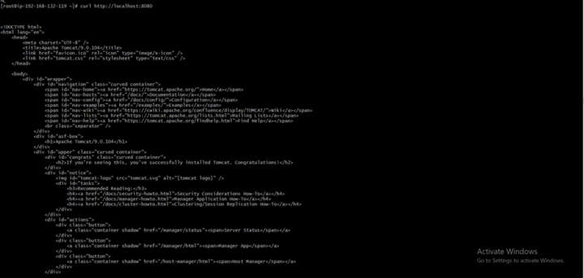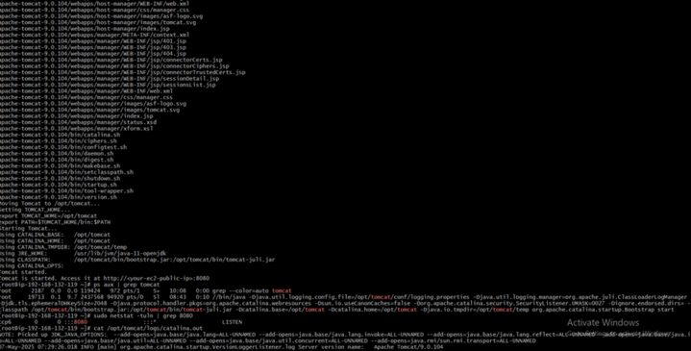

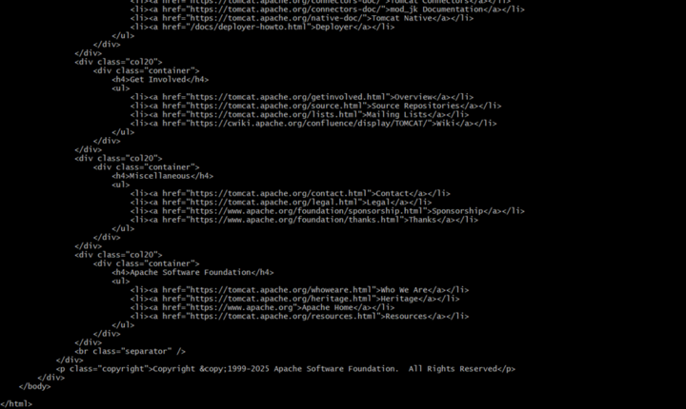

1. COnfigure VPC flow logs and store the logs in s3 and cloudwatch.

* firstly you need to create the vpc
* you need to go log groups and create the log groups
* now you need to go vpc console and go to flow logs and create the cloud watch in that select the cloud watch >atach the log groups >create the flow logs .
* Go to the S3 console and create the bucket > give the name> create the bucket
* then go to flow logs>select the s3>select the bucket>crreate thet flow log
* to verify the cloud watch>go to log groups>selct log groups you can see the logs
* to verify the s3 >go to the buckets and slects buckts files you see the files

